**Technical Manual for Polling Personnel Randomisation**

We presume that database preparation is over and all required tables *(subdivision, assembly, bank, branch, block_muni, district, policestation, environment, govtcategory, institute, language, qualification, remarks, office, personnel*) along some other tables like *menu, submenu, user, user_permission, poststat* and *poststatorder* are already populated.

Now , we may go for first randomisation .

**A. First Randomisation :**

Tables associated with first randomisation other than some master tables as mentioned above are –

*Assembly_party , personnela, training_pp, training_venue, training_type, training_schedule , first_rand_table, reserve, replacement_log_pregroup, tblsms*

**A1. Entering Assembly Vs Party as well as Reserve :**

*Menu*  : ( Master-> Assembly_party)

*How to enter* : Say you are entering information for Barabani assembly of Asansol Subdivision . They require 100 nos. 4-member party , 50 nos. 5-member party and 10 nos. 6-member party.

Then select ASANSOL against Subdivision , BARABANI for assembly , screen will be same as shown below..

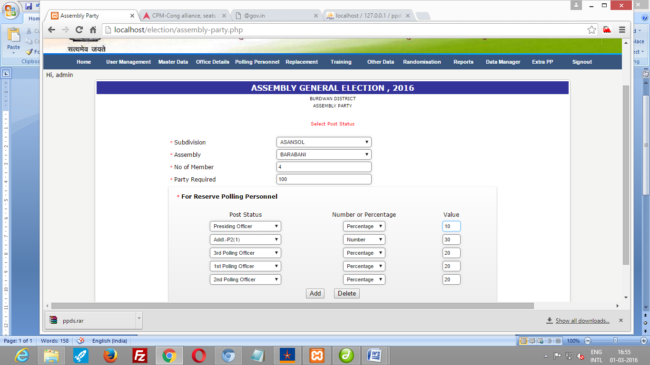

Here ,at first , *no_of_member* is 4 and *party required* is 100 . Information for requirement of reserve is lower part of screen , For each category 20 % reserve requirement has been given whereas for Addl P2, it is given in number i.e. 30 . Use Add button to add reserve for each post status . Then click SUBMIT button to save all .

As you require , 50 number of 5-member party , pls go similar way , with

Number of member as 5 and Party Required as 50.Enter reserve information.

*Complete for all assembly under the subdivision.*

If you are going for randomisation district-wise , then under district ( Subdivision) enter all assembly and related information.

*Technical Info :* Here assembly_party & reserve tables will be populated.

Related menu for updating is , Master 🡪 Assembly Party List ( Delete )

**A2. Swapping (Xtra) :**

Here , Swapping means selecting required number of PP for a subvision/district from the complete database. Technically , data is transferred from personnel to personnela table. This step is a must to start randomisation.

*Menu :* ( Polling Personnel 🡪 Swapping )

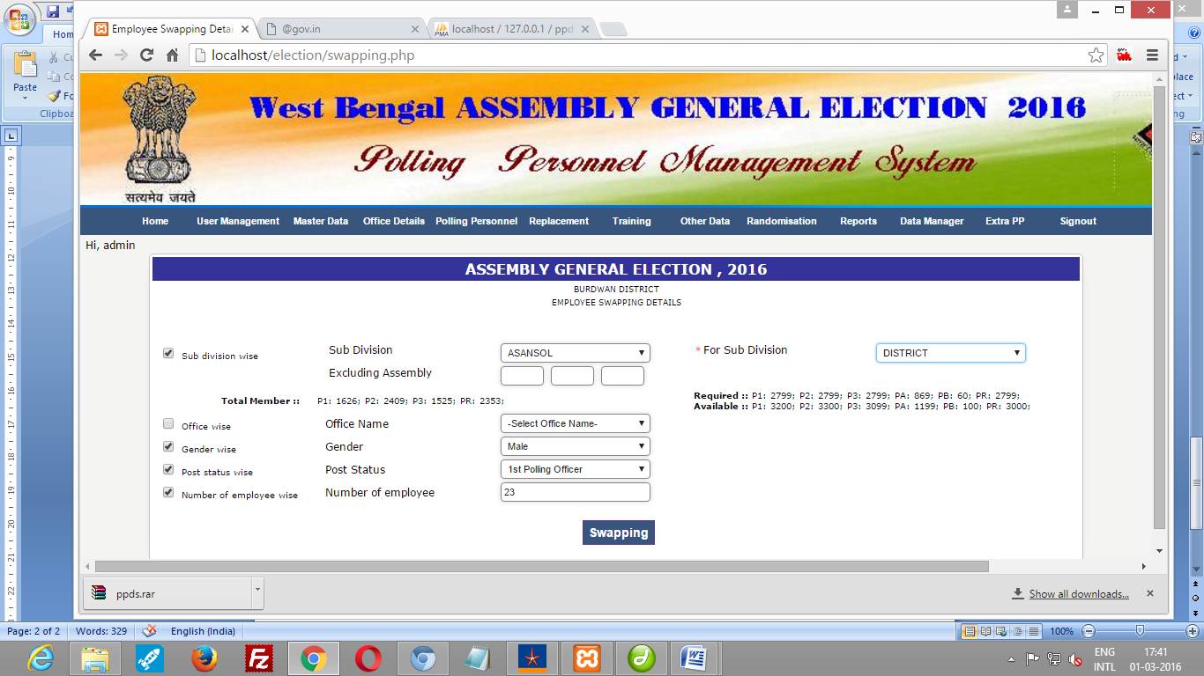

Check the *Subdivision wise (extreme upper-left position)* to enable the other combos. In the left side , you will have to select a subdivision *from where PP will be taken*. After selection, category wise total no of PP will be displayed. In the right side, you will have to select a subdivision where PP will be drafted. After selecting subdivision/diatrict , category wise total no of required PP will be displayed as well as category wise total no of swapped PP will be displayed.

You may exclude three assemblies so that PP whose office , permanent address and present address are in those assemblies , will not be taken.

It is also possible to select office , Gender, post status and number of PP at the time of swapping for the selected subdivision. If you only select Subdivision , then entire personnel of that subdivision would be swapped.

*Technical Info :* After swapping , PP at *personnel* table will have f_cd =1 ( changed from null to 1) and the same record will be populated into *personnela* table. In personnela table *for_subdivision* field will be populated with subdivision code for which PP has been drafted.

**A3. Reverse Swapping (Xtra) :**  If you want to swap back the personnel that remained unused , the Reverse Swapping is to be done. Here data at personnela will be deleted and for that PPl , f_cd field at *personnel* table would be set null. Here , PP who has already been selected will not be reverse swapped.

Menu : ( Polling Personnel 🡪 Reverse Swapping (Xtra) )

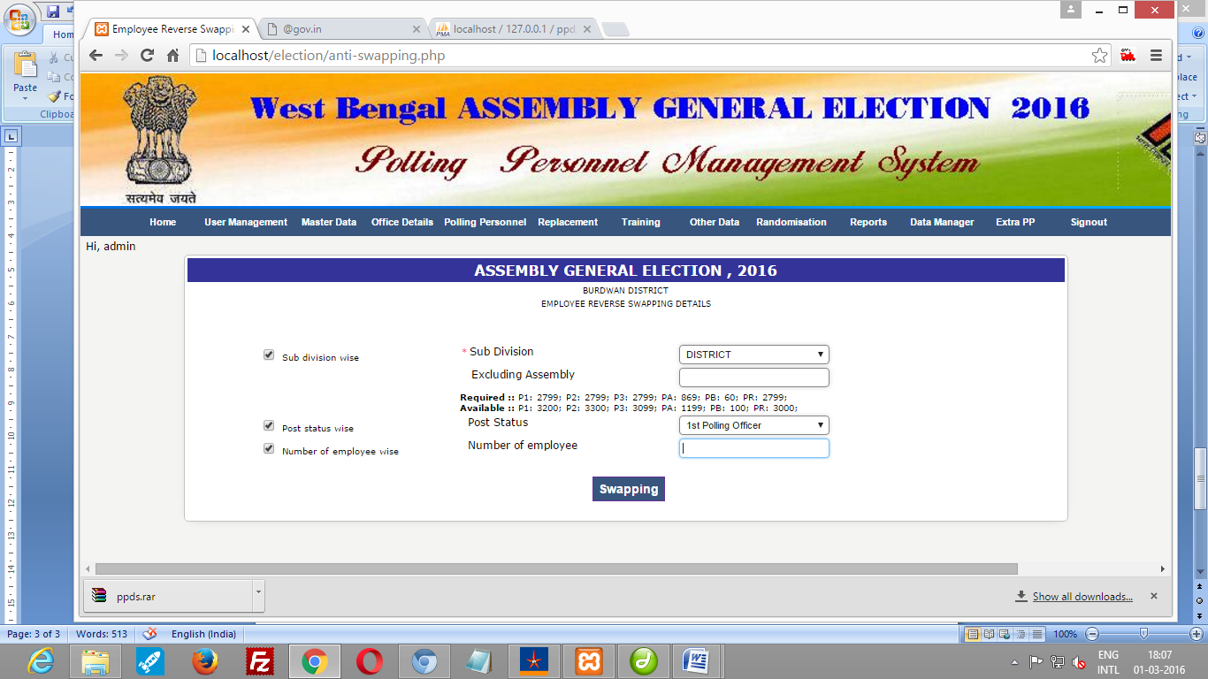

Check the *Subdivision wise (extreme upper-left position)* to enable the other combos. You will have to select a subdivision *from where PP will be reversed back*. After selection category wise total no of required PP will be displayed as well as category wise total no of swapped PP will be displayed.

You may exclude one assembly so that PP whose office , permanent address and present address is in that assembly will not be taken.

It is also possible to select post status and number of PP at the time of reverse swapping for the selected subdivision. If you only select Subdivision , then entire personnel ( not booked) of that subdivision would be reversed back.

Another menu **. Reverse Swapping ...** here all PP irrespective of booked or not will be reverse swapped.

*Technical Info :* PP will be deleted from personnela table and in personnel table f_cd will be null

**A4. Randomisation :**

In first randomisation we select the PP for poll duty.

Menu : (Randomisation🡪 First Randomisation )

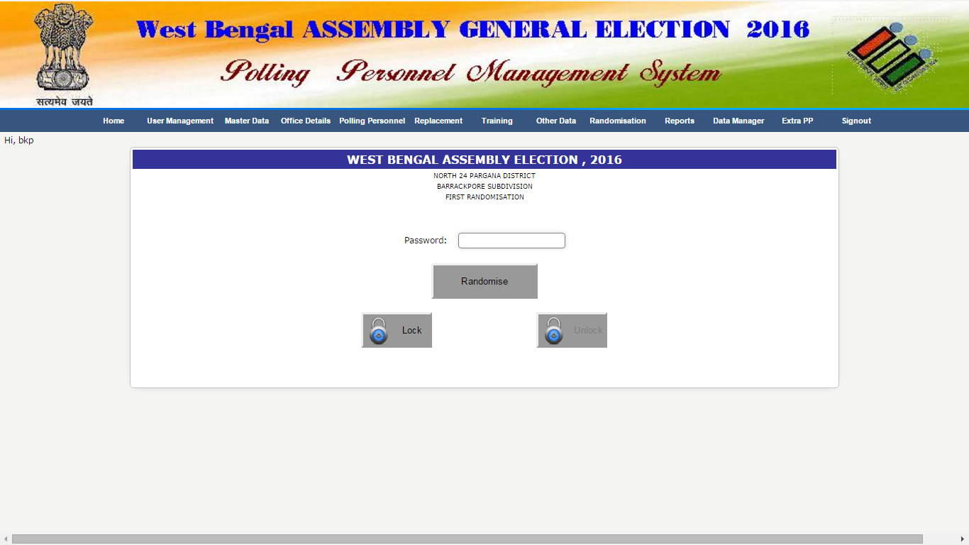

For the first time set the password for first randomisation. Click on CLICK HERE. After clicking default password (admin) will be set.

Click on *Randomise*  button for first randomisation.

Click on LOCK button after randomisation to avoid further randomisation because on every click different set of PP will be selected. You may unlock and after locking using randomisation password if required.

*Technical Info :* In *personnel a* table will have *selected* =1 (changed from null to 1), *booked*=*P* or *R* where the user’s subdivision=for_subdivision as per requirement given in *assembly_party* and *reserve* table. For district wise randomisation user will be district (subdivision).

**A5. Training Requirement :**

This is used to select randomised PP whose first training are required. Required information are Training Type (First Training), Post Status (PR/P1/P2 etc.) and subdivision (where PP are drafted i.e. for_subdivision)

*Menu :* (Training🡪 First Training Requirement )

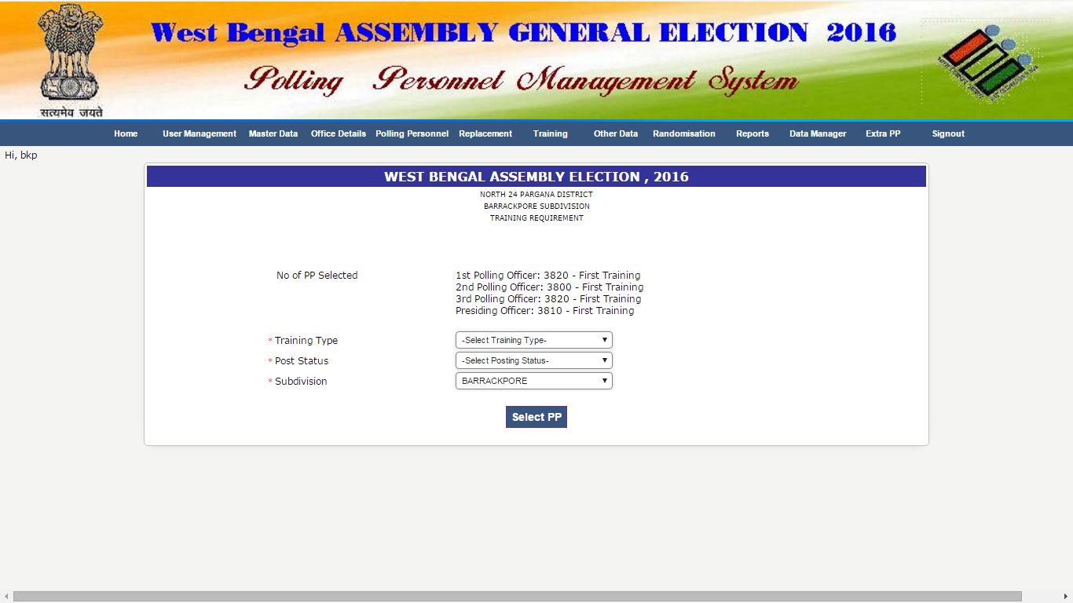

*Technical Info :* selected PP for poll duty (through First Randomisation) will be populated in training_pp table. Select all PP of all post status.

**NOTE :** Requirement should be fulfilled for every selected PP otherwise first appointment letter will not be printed. If one category (say P3) is not included for first training then you should not allocate training to them but must select them in training requirement.

**A.6 Training Venue** :

Here training venue information is entered . This job may be done anytime, but before going for first training Allocation.

Menu : (Training 🡪 First Training Venue )

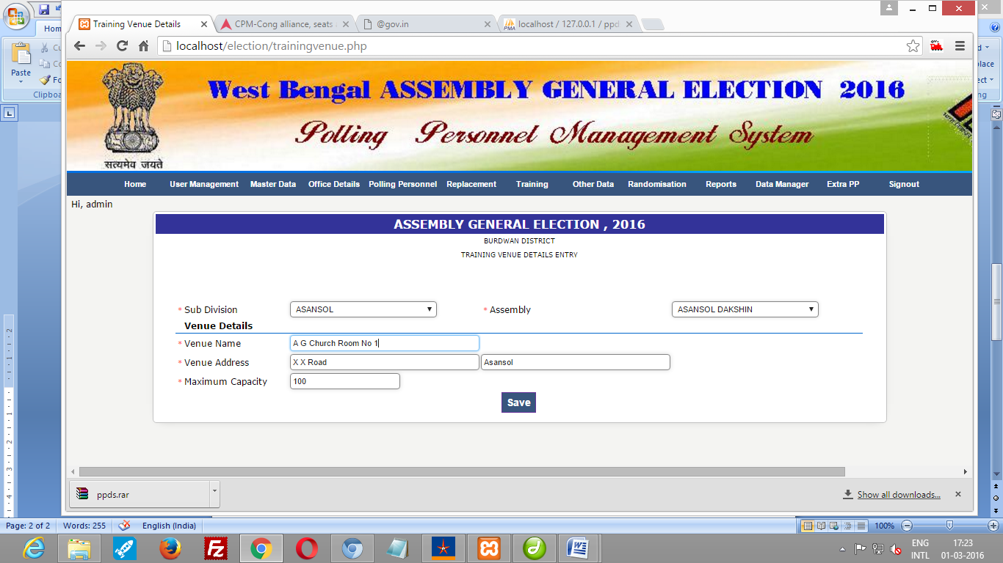

*Technical Info :* Here training_venue table will be populated.

Related menu for updating is, Training 🡪 First Training Venue List

**A7. Training Allocation :**

This is required for allocating training schedule for a PP. Here , venue, date, time and number of PP in a schedule is entered .

*Menu :* (Training🡪 First Training Allocation)

The required information are

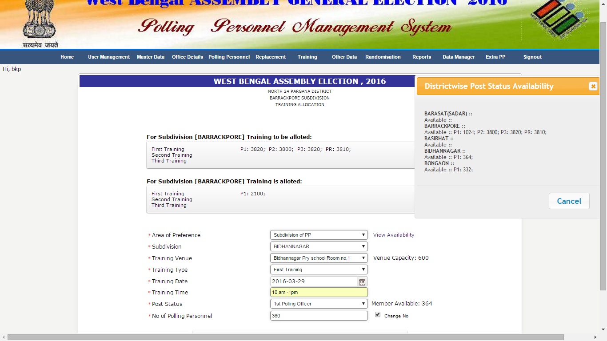

Area of Preferance

[options are subdivision of PP (office subdivision of PP– first 4 digit of PIN), Allotted subdivision ( for_subdivision), Assembly of Temp. Address, Assembly of Perm. Address, Assembly of Office Address)] where training will be given. Accordingly subdivision/assembly will be populated for choosing.

Training venue ( shows the capacity of the venue),

Training Type ( First Training)

Training Date,

Training time,

Post status (shows member available for selected category)

No. Of Polling Personnel [ Shows the maximum capacity of the venue but can be changed (by checking Change No.) according to availability of member]

To view the availability of members from different subdivisions , click on VIEW AVAILABILITY.

*Technical Info :* training_schedule table will be populated along with updation of schedule code in training_pp table.

Related menu for updating is, Training 🡪 First Training Allocation List

**A8. Token generation (Optional)**

This is used for venue wise – post status wise generation of token for training.

*Menu :* (Training🡪 Token)

Click on TOKEN CREATE button.

*Technical Info :* token field of training_pp table will be updated

**A10. First Appointment Letter population.**

It is required for printing First Appointment Letter.

*Menu :* (Randomisation🡪 First App. Letter populate)

Click on POPULATE button.

*Technical Info :* subdivision wise, Block-municipality wise, office wise PP data will be populated in first_rand_table

**A11. Save SMS :**

It is used for generating SMS Text.

*Menu :* (Other data🡪 Save SMS for PP)

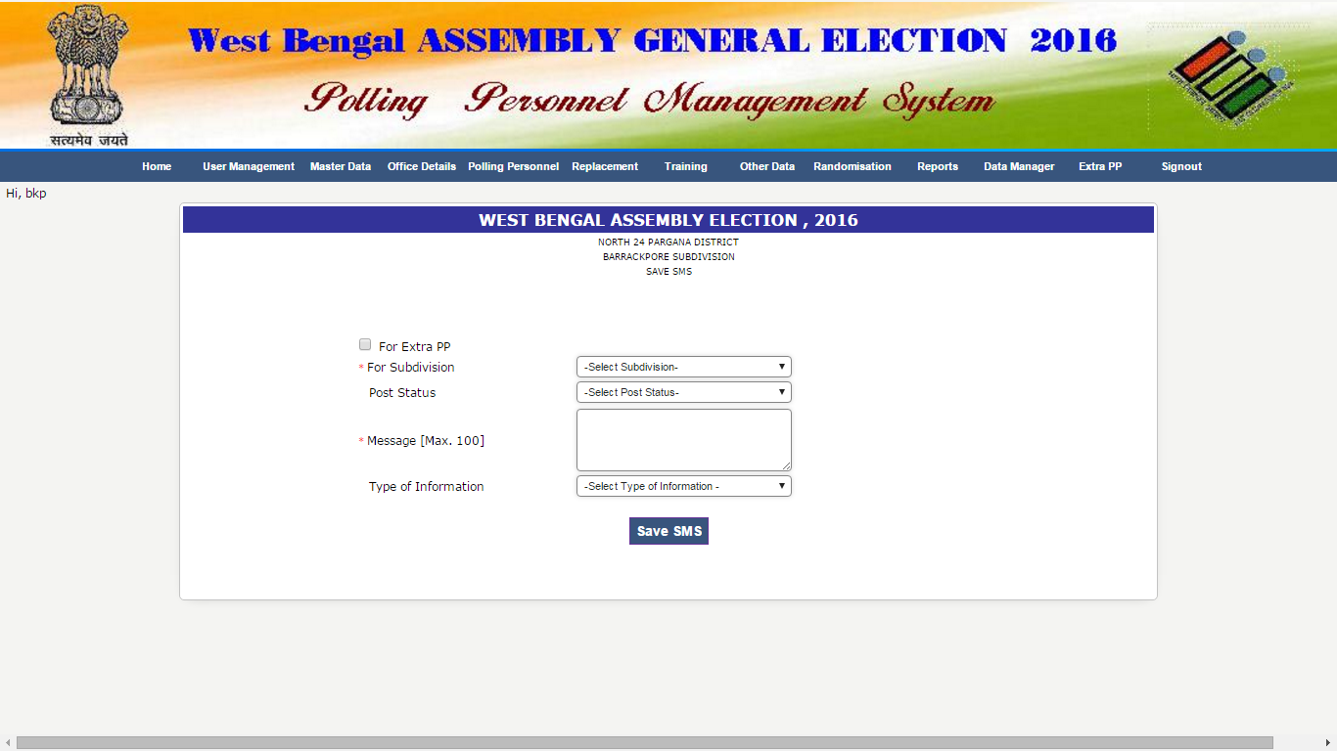

Select Subdivision, Post status (optional), Message , Type of Information (optional)

*Technical Info :* text will be populated in tblsms

**NOTE:**  You can send SMS, other than the prescribed format by populating tblsms table.

**A12. Send SMS**

It is used for sending SMS.

*Menu :* (Other data🡪 Send SMS)

Select the limit (maximum 200) and click on SEND SMS button.

**A13. Replacement**

It is used for replacing an selected PP after first randomisation.

*Menu :* (Replacement🡪 Pre-group Replacement)

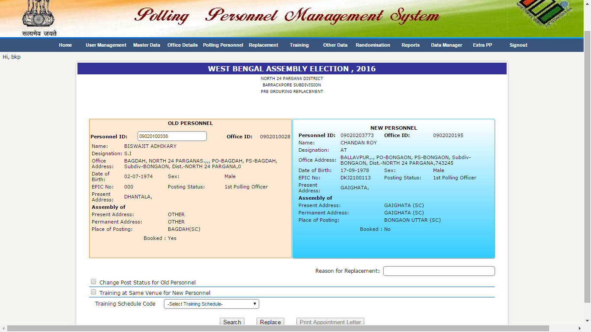

After Giving the PIN of PP the details of PP will be displayed on left side. Click on SEARCH button to find the PP for replacement considering all prescribed conditions. Put the Reason for Replacement (optional). Now Click on REPLACE button to replace. Click on PRINT APPOINTMENT LETTER button for getting appointment letter.

Conditional Replacement :

1. If the PP appeared for replacement, want to do the duty with another post status then CHECK the *Change Post Status for Old Personnel* . The Old PP will available for next replacement in personnela table with changed post status and simultaneously a new PP will replace him .
2. By default the training schedule of Old PP will tag with New PP but if the new PP required a new training schedule then UNCHECK the *Training at Same Venue for New Personnel* and the system will ask for new training schedule. New Training schedule should be entered through the menu *Training -> Special Training (Pre-Group Replacement)* previously.

*Technical Info :* In *personnela* table a ‘C’ is placed in *booked* field of old personnel (if post status is not changed, in this case it will be blank and rand_no will be 0) and the value (P/R) of booked field of old personnel is placed in that of new personnel.

**A14. Cancellation**

It is used for cancelling an selected PP after first randomisation.

*Menu :* (Replacement🡪 Pre-group Cancellation)

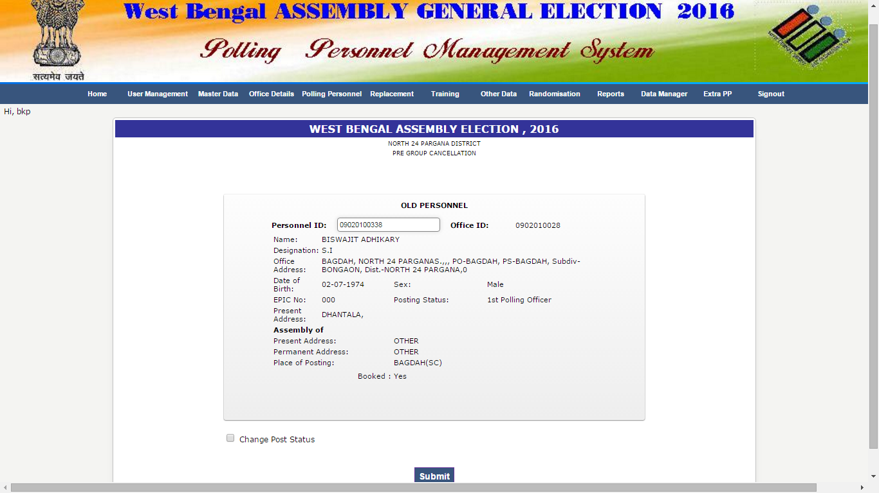

After Giving the PIN of PP the details of PP will be displayed. Click on SUBMIT button to cancel the PP.

Conditional Cancellation :

If the PP appeared for cancellation, want to do the duty with another post status then CHECK the *Change Post Status*. This PP will available for next replacement in *personnela* table with changed post status.

*Technical Info :* remove the PP from personnela table. If post status is changed then it wil remain in *personnela* table

**A15. Show Cause**

It is used for issuing show cause letter to the PP who is not attended the first training programme.

*Menu :* (Training🡪 First Training Attendance)

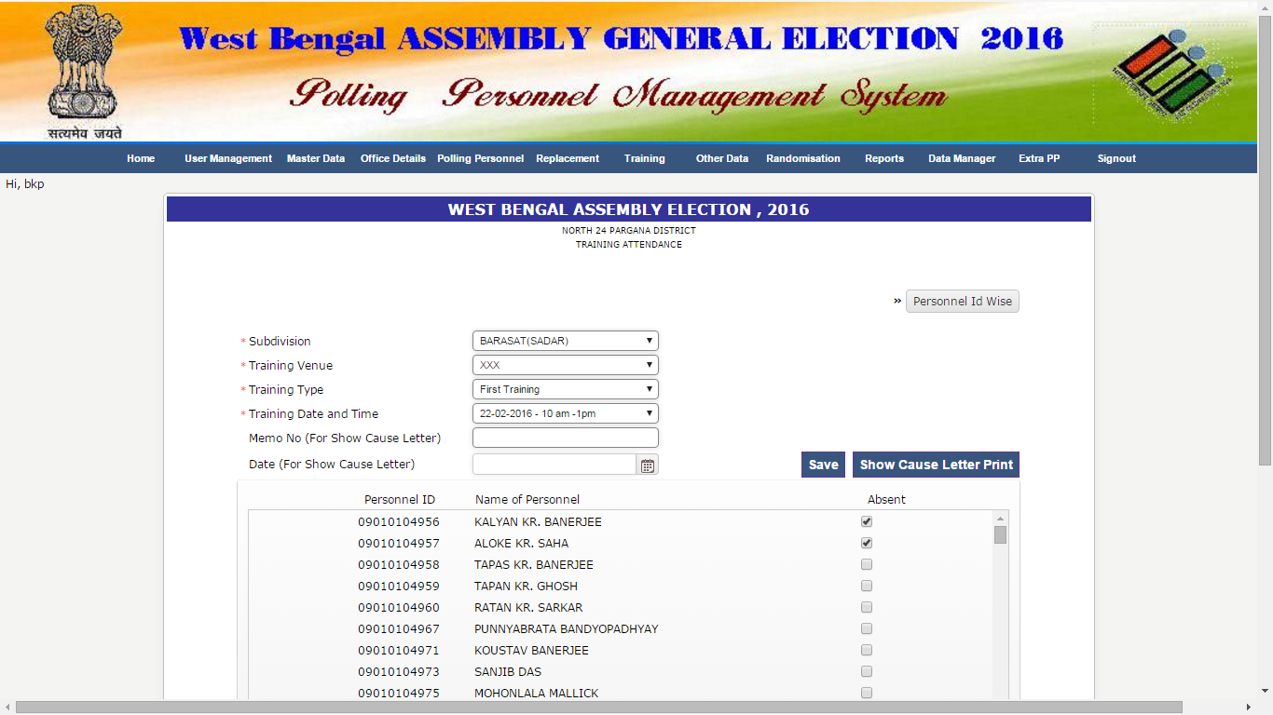

After selecting Subdivision, Training Venue, Training Type and Training Date and Time a list of PP of selected inputs appears. Check the box against absent PP. SAVE it. Put memo no. and date for show cause letter. Click on SHOW CAUSE LETTER PRINT.

System provides an option to print the PERSONNEL ID WISE Show Cause letter.

*Technical Info :* In *training_pp* table a ‘A’ is placed in *training_attended* field.

**A16. SPECIAL CASE :**

**ONE : Randomisation after finalisation**

After locking First randomisation process, if it is required to do again, follow the steps below..

1. First Radomisation
2. Training Requirement
3. First Training Assign

It is used for assigning training to the new set of PP generated in next randomisation using existing training schedule.

*Menu :* (Training🡪 First Training Assign)

Select the training type (First Training) and click on SUBMIT button.

1. Training Allocation

It is required if ‘’Training assign not fulfilled’’ message comes after running above step.

**TWO : Extra PP**

It is used when more PP is needed to be entered freshly for any reason.

1. Swapping

(populates into personnel a table without randomisation)

1. First Training Requirement

(populates extra PP into training_pp table)

1. Training Allocation

(makes new training schedule for extra PP)

1. Token (Optional)

(generates token for extra PP)

1. First App. Letter Populate

(generates appointment letter for extra PP)

**A17. REPORTS after First Radomisation**

*Menu :* (Reports🡪 ......)

1. Office wise PP List
2. Subdivision wise PP List
3. Venue wise List
4. First App. Letter (Personnel ID wise)
5. First App. Letter (Subdivision wise)
6. First App. Letter (Office wise)

**B. Second Randomisation :**

Tables associated with second randomisation other than some master tables as mentioned above are –

*dcrcmaster, dcrc_party, grp_dcrc, Assembly_party, poll_table, training_venue_2, second_training, personnela, second_appt, second_rand_table_reserve, poststatorder, replacement_log, replacement_log_reserve, tblsms2*

**B1. Entering DC-RC :**

It is used to enter the details of distribution centre and receiving centre of poll materials.

*Menu*  : ( Master-> DCRC Master)

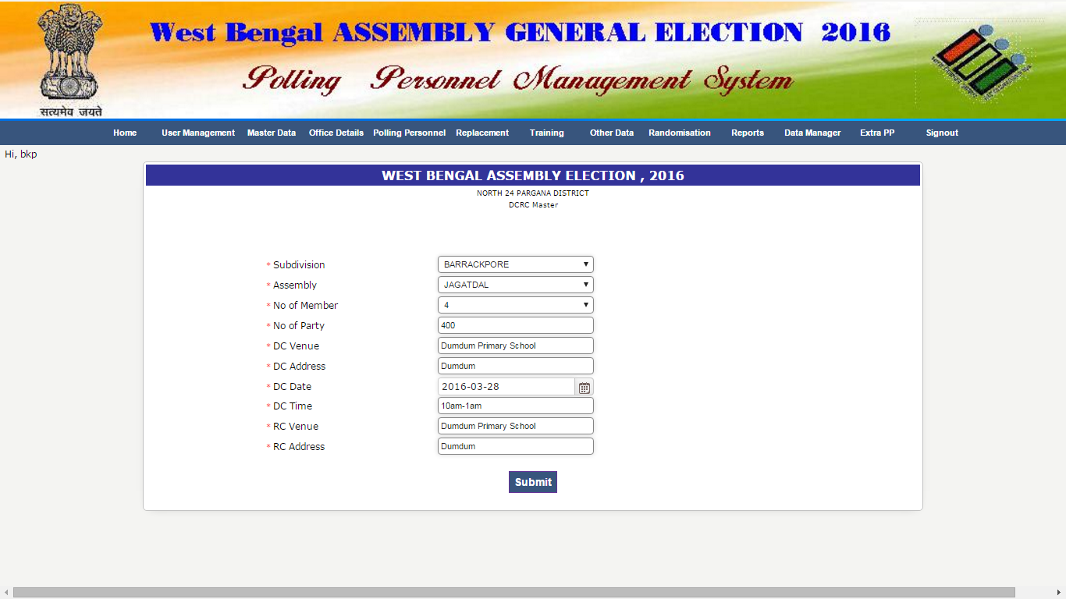

After selecting Subdivision, Assembly, No of Member, No. of Party, type DC Venue, DC Address, DC Date, DC Time, RC Venue, RC Address and click on SUBMIT button.

*Technical Info :* Here dcrcmaster & dcrc_party tables will be populated.

Related menu for updating is , Master 🡪 DCRC Master List (Edit)

**B2. Radomisation :**

In second randomisation we form the polling party for poll duty.

Menu : (Randomisation🡪 Second Randomisation )

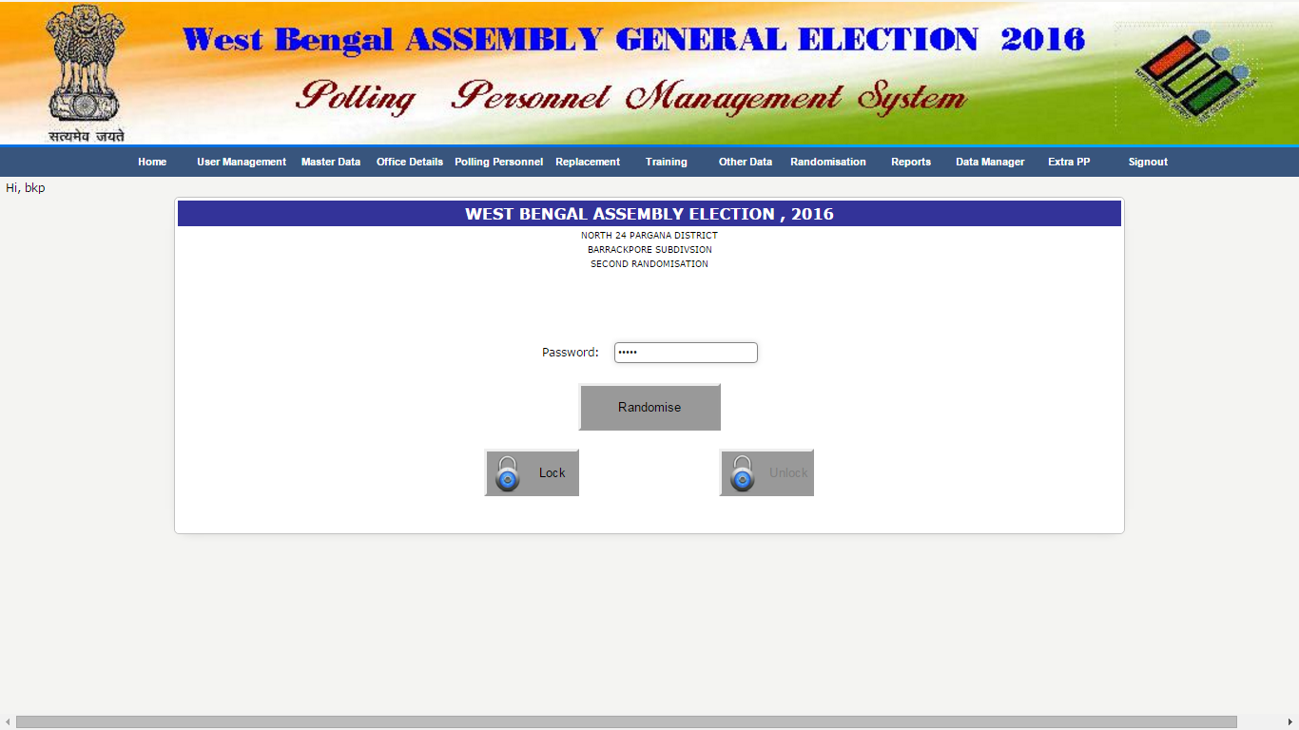

For the first time set the password for second randomisation. Click on CLICK HERE. After clicking default password (admin) will be set.

Click on *Randomise*  button for second randomisation.

Click on LOCK button after randomisation to avoid further randomisation because on every click different set of polling party will be selected. You may unlock and after locking using randomisation password if required.

*Technical Info :* In *personnela* table will have *booked*=*P* or *R, and for_assembly* where the user’s subdivision=for_subdivision and *selected* =1 as per requirement given in *assembly_party* and *reserve* table. For district wise randomisation user will be district (subdivision).

**B3. Training Venue** :

Here training venue information is to be given . This job may be done anytime, but before going for second training Allocation.

Menu : (Training 🡪 Second Training Venue )

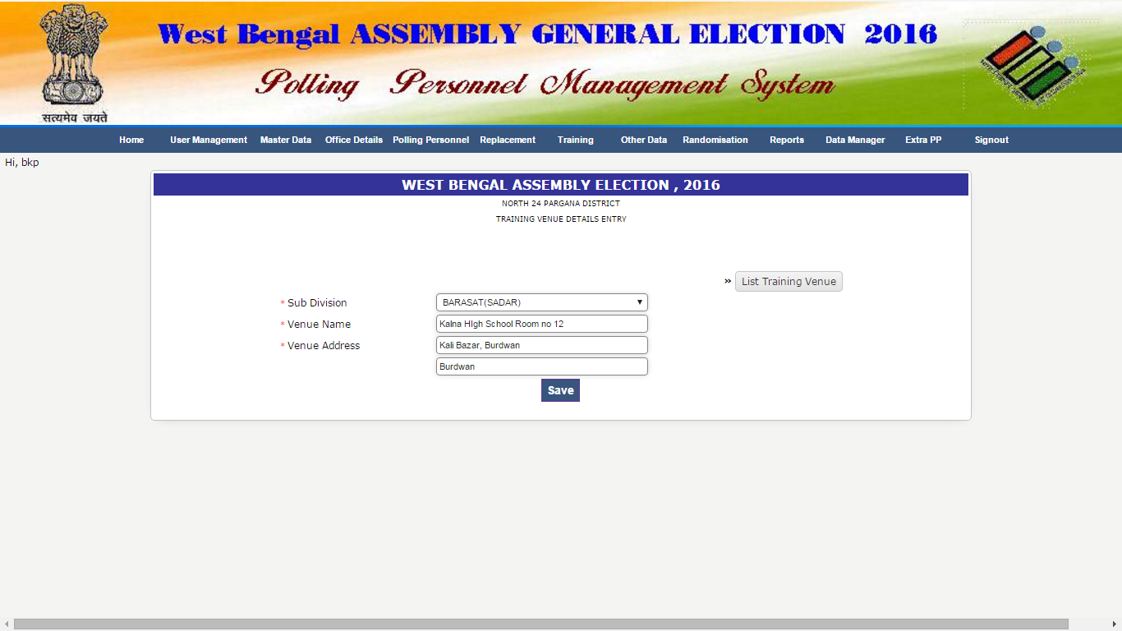

After selecting subdivision venue name and venue address are to be entered.

*Technical Info :* Here training_venue2 table will be populated.

For updating click on LIST TRAINING VENUE button

**B4. Training Allocation :**

This is required for entering venue, date, time etc.

*Menu :* (Training🡪 Second Training Allocation)

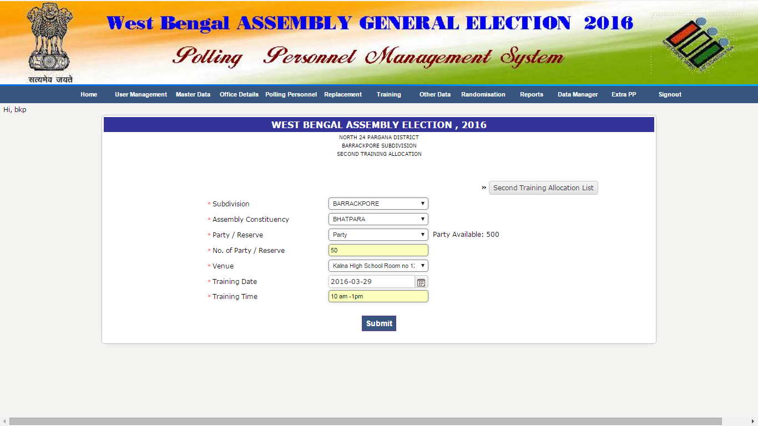

After selecting Subdivision, Assembly Constituency, Party/Reserve, Type No. of Party/Reserve Venue, Training Date, Training Time. Click on SUBMIT

*Technical Info :* second_training table will be populated along with updation of *training_schedule* field in *personnela* table.

For updating click on SECOND TRAINING ALLOCATION LIST button

**B5. Second Appointment Letter population.**

It is required for printing Second Appointment Letter for polling party.

*Menu :* (Randomisation🡪 2nd. App. Letter populate)

Click on POPULATE button then MULTIPLY button then SERIAL button.

*Technical Info :* Polling Party data will be populated in second_appt table

**B6. Second Appointment Letter population (Reserve)**

It is required for printing Second Appointment Letter for reserve polling personnel.

*Menu :* (Randomisation🡪 2nd. App. Letter populate (Reserve)

Click on POPULATE button then SERIAL button.

*Technical Info :* Reserve Polling Personnel data will be populated in *second_rand_table_reserve* table

**B7. REPORTS after Second Radomisation**

*Menu :* (Reports🡪 ......)

1. Second App. Letter (Subdiv or Assembly wise)
2. Second App. Letter (Office wise)
3. Second App. Letter (Reserve)
4. Scroll / Master Roll Report
5. Master Roll Report (Reserve)

**B8. Replacement**

**1.** It is used for replacing an PP of a polling party with a fresh PP (booked=blank) after second randomisation.

*Menu :* (Replacement🡪 Post-group Replacement- (New PP)

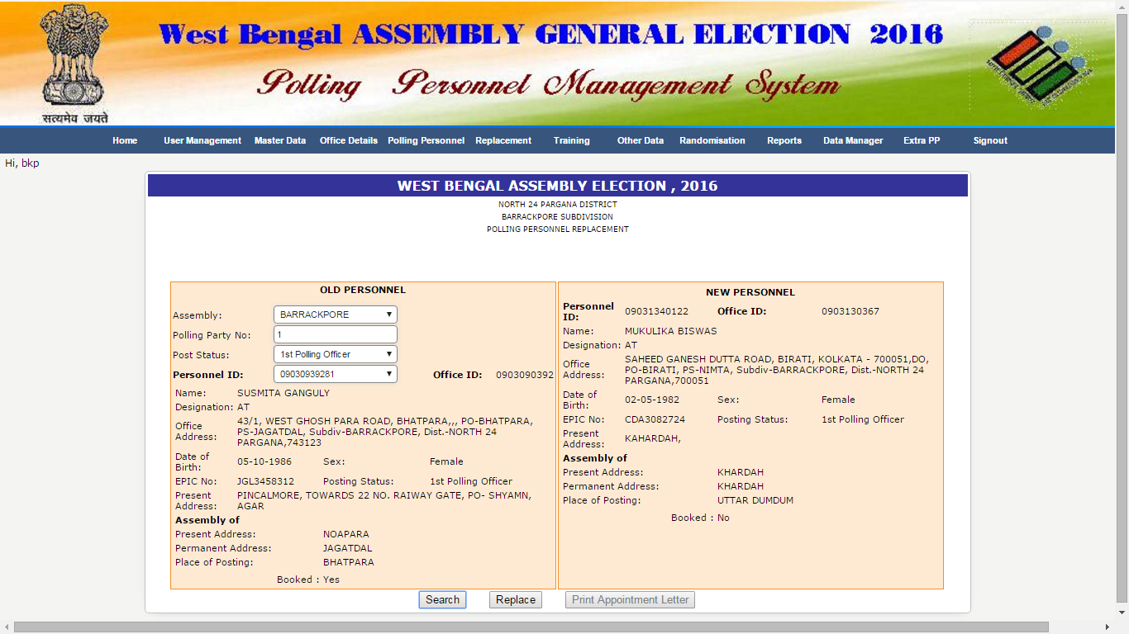

After selecting Assembly, Polling Party No., and post status details of PP will be displayed below. Click on SEARCH button to find the PP for replacement considering all prescribed conditions. Now Click on REPLACE button to replace. Click on PRINT APPOINTMENT LETTER button for getting appointment letter.

*Technical Info :* In *personnela* table a ‘C’ is placed in *booked* field of old personnel and the value (P) of booked field and relevant data of old personnel is placed in that of new personnel . Also second_appt table is being updated.

**2.** It is used for replacing an PP of a polling party with a reserved PP (booked=R) after second randomisation.

*Menu :* (Replacement🡪 Post-group Replacement- (Reserve PP)

After selecting Assembly, Polling Party No., and post status details of PP will be displayed below. Click on SEARCH button to find the PP for replacement considering all prescribed conditions. Now Click on REPLACE button to replace. Click on PRINT APPOINTMENT LETTER button for getting appointment letter.

*Technical Info :* In *personnela* table a ‘C’ is placed in *booked* field of old personnel and the value (P) of booked field and relevant data of old personnel is placed in that of new personnel (booked=R). Also second_appt table is being updated.

**3.** It is used for interchanging of post status between two PPs of a polling party after second randomisation.

*Menu :* (Replacement🡪 Post-group Replacement- (Post Status)

After selecting Assembly, Polling Party No., and post status details of PP will be displayed on left side according that of the second PP on the right side. Now Click on REPLACE button to interchange. Click on PRINT APPOINTMENT LETTER button for getting appointment letter.

*Technical Info :* post status are interchanged in *personnela* table. Also second_appt table is being updated.

**4.**  It is used for replacing a reserved PP with a fresh PP (booked=blank) after second randomisation.

*Menu :* (Replacement🡪 Reserve PP Replacement- (New PP)

After Giving the PIN of PP the details of reserve PP will be displayed on left side. Click on SEARCH button to find the fresh PP for replacement considering all prescribed conditions. Now Click on REPLACE button to replace. Click on PRINT APPOINTMENT LETTER button for getting appointment letter.

*Technical Info :* In *personnela* table a ‘C’ is placed in *booked* field of old personnel and the value (R) of booked field and relevant data of old personnel is placed in that of new personnel . Also *second_rand_table_reserve* table is being updated.

**B9. Cancellation**

It is used for cancelling an reserve PP after second randomisation.

*Menu :* (Replacement🡪 Reserve PP Cancellation)

After Giving the PIN of PP the details of PP will be displayed. Click on SUBMIT button to cancel the PP.

*Technical Info :* remove the PP from *personnela* and *second_rand_table_reserve* table.

**B10. Save SMS :**

It is used for generating SMS Text after 2nd randomisation.

*Menu :* (Other data🡪 Save SMS (Second Training)

Select Subdivision, Party / Reserve, Post status (optional), Message , Type of Information (optional) and click on SAVE SMS

*Technical Info :* text will be populated in tblsms2

**NOTE:**  You can send SMS, other than the prescribed format by populating tblsms table.

**B11. Send SMS**

It is used for sending SMS.

*Menu :* (Other data🡪 Send SMS (Second Training)

Select the limit (maximum 200) and click on SEND SMS button.

**C. Third Randomisation :**

Tables associated with third randomisation other than some master tables as mentioned above are –

*pollingstation, Assembly_party, personnela*

**C1. Randomisation :**

In third randomisation polling party is tagged with polling station.

*Menu :* (Randomisation🡪 Third Randomisation )

For the first time set the password for third randomisation. Click on CLICK HERE. After clicking default password (admin) will be set.

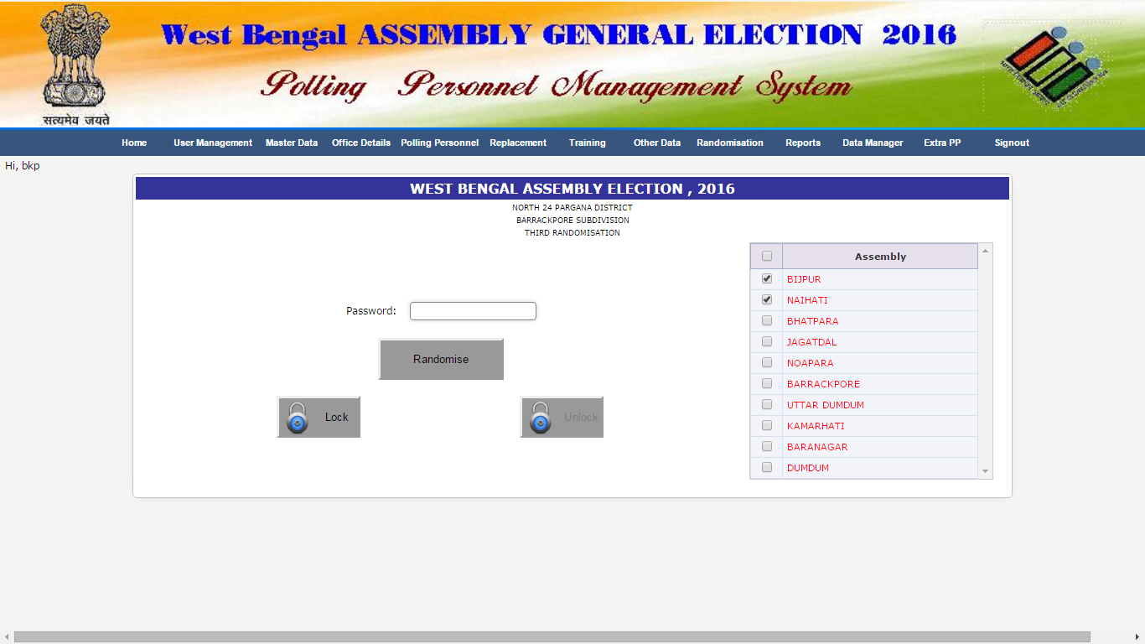

Now check the Assembly/Assemblies for which third randomisation will take place from right side pan.

Click on *Randomise*  button for third randomisation.

Click on LOCK button after randomisation to avoid further randomisation because on every click different set of polling party will be tagged with different set of polling stations. You may unlock and after locking using randomisation password if required.

*Technical Info :* Polling station table will be populated. For district wise randomisation user will be district (subdivision).

**C2. REPORTS after Third Randomisation**

*Menu :* (Reports🡪 Booth Tagging List )